Capstone 2: Nutrition Platform

Object: The purpose of this platform is the user to find the nutrition products base on the product name or the barcode that the user can type in. The design of this platform will base on the fatsecretplatform api which can be access from the following link below.

<https://platform.fatsecret.com/docs/v1/food.find_id_for_barcode>

With this platform the user can choose their diet base on the calories.

Design Phase: The design phase of this product will include the following functions:

1. User Login Window
2. Product Search Functionality
3. Product Search by Food Brands
4. Product Search by Category Types
5. Display of Calorie Intake

Using the search interface depicted in Figure 1, users can conduct searches based on either an AND or OR combination of barcode, brands, and categories.

After locating the items, users can add them to their profiles as illustrated in Figure 2.

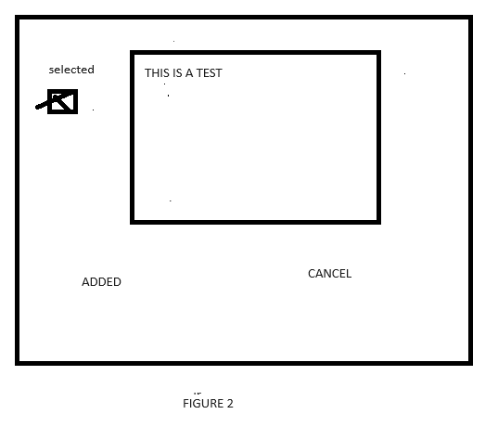

**CALORIES WINDOW**

If users later decide they only want to consume 300 calories, they can utilize the form below for their search. This form will provide users with all the necessary items based on the criteria of the search.

Top of Form

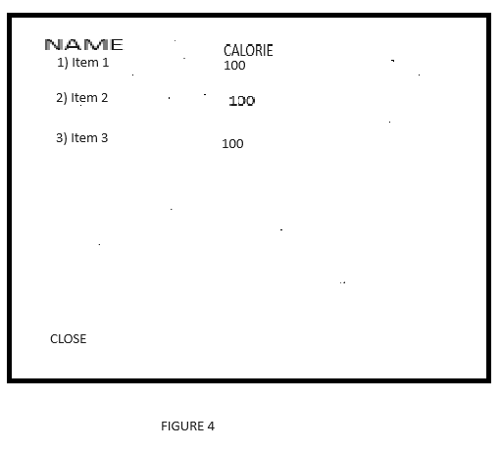

After that it will display the list of items like the figure 4 below.